

SImulation based analysis of low noise amplifier



ROhit Ganguly

RITWIKA DAS

## INDEX

**1. Acknowledgement**

**2. Introduction**

**(Requirement of low noise amplifiers, some methods of reducing noise,**

**applications)**

**3. Components**

**a. MOSFET**

**b. HEMT**

**c. Comparison**

**4. Basic Class A amplifier using MOSFET**

**5. Stability concept**

**a. Bode plot**

**b. Gain Margin, Phase margin**

**c. Pole-zero concept**

**d. Polar plot and stability**

**6. Noise in amplifiers a. Type of noise**

**7. Simulation of basic circuits**

**a. LPF, HPF, BPF, BSF sing lumped components**

**b. Op-amp based Amplifier**

**c. CASCODE amplifier using BJT**

**8. Simulation of a low noise amplifier**

**a. Device parameters (CE3512K2-C1)**

**b. HEMT based tuned amplifier**

**c. Performance analysis**

**(Analysis of Bode plot and polar plot)**

**9. Conclusion**

1. **Acknowledgement**

We would like to express our special thanks to our Professors , Professor Sanghamitra Poddar and Dr. Malay Ganguly, Head of The Department, Electronics and Communication Engineering, Institute of Engineering and Management, Kolkata, for giving us the opportunity to undergo this training at Variable Energy Cyclotron Center, Kolkata.

We would also like to express our gratitude to Mr. Niraj Chaddha, our guide, for giving us the opportunity to work with him and guiding us during the course of the project. We would like to thank Dr. P. Y. Nabhiraj, Head, ECRIS Section and Training Coordinator, VECC for his kind support and encouragement, and for the opportunity that he has given us to carry out our summer training at this highly reputed organization.

1. **Introduction**

The basic concept of this report is the fundamental study of low noise amplifier and the related lumped components (resistors, inductors, capacitors etc) that are required in the field of electronics, at very low temperature. Analog Devices low noise amplifiers cover the frequency range from DC (IF) to RF Microwave and W-Band (95 GHz). These MMIC-based designs cover various gains and bandwidths with noise figures as low as 0.7 dB. Our low noise amplifiers offer some of the lowest noise and highest linearity available in the industry. Many of the designs offer a self-biased topology, and are internally matched to 50 ohms. They are used in a wide range of applications including telecom, instrumentation, and military/aerospace. All Analog Devices low noise amplifiers are fully specified over frequency, temperature, and supply voltage Several circuits both easy and complex were designed and framed and were studied to get a proper analysis of them. Starting from simple high pass filter circuit to complex amplifier circuits all were designed and simulated. All the characteristic plots were made and the output was analysed to check the stability of the system. A simulation software name Advanced Design System , developed by Keysight Technology, was used to simulate the circuits and based on the simulation the response was analysed. Thus, the stability and the responses were monitored in this operation.

**III.Components**:

1. **MOSFET**

MOSFET is an acronym for Silicon Metal Oxide Field Effect Transistor or Metal Oxide Semiconductor Field Effect Transistor. This is also called IGFET, which stands for Insulated Gate Field Effect Transistor.

FET works in both depletion and enhanced mode. The figure below shows what a practical MOSFET looks like the figure below:

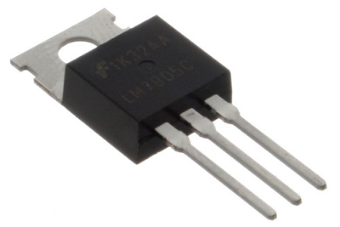

## Construction of a MOSFET

## The structure of MOSFET is somewhat similar to FET. The oxide layer is deposited on the substrate connected to the gate terminal. This oxide layer acts as an insulator (SiO2 is isolated from the substrate), so another name for MOSFET is IGFET.

## In the construction of the MOSFET, the lightly doped substrate diffuses with heavily doped regions. Depending on the substrate used, they are called p-type and n-type MOSFET

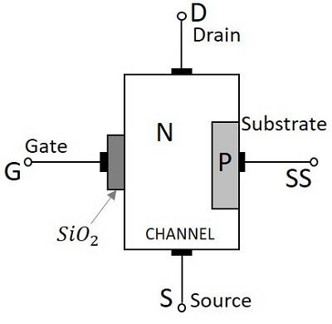

The gate voltage controls the operation of the MOSFET.

In this case, positive and negative voltages can be applied to the gate because it is isolated from the channel. For negative gate bias voltage, it acts as a depletion mode MOSFET, and for positive gate bias voltage, it acts as an enhancement mode MOSFET.

1.2 **Classification of MOSFETs**

Depending upon the type of materials used in the construction, and the type of operation, the MOSFETs are classified as in the following figure.

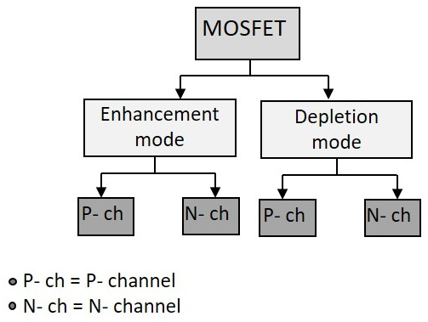

The N-channel MOSFETs are simply called as NMOS. The symbols for N-channel MOSFET are as given below.

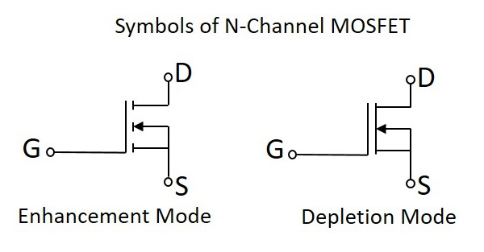

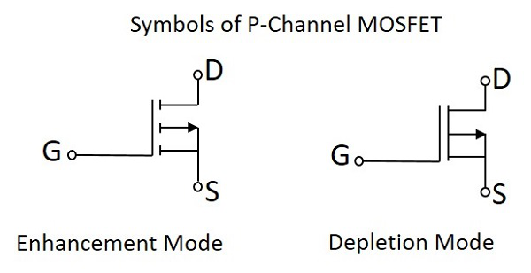The P-channel MOSFETs are simply called as PMOS. The symbols for P-channel MOSFET are as given below.

1.3 **Drain Characteristics**

The drain characteristics of a MOSFET are drawn between the drain current ID and the drain source voltage VDS. The characteristic curve is as shown below for different values of inputs**.**

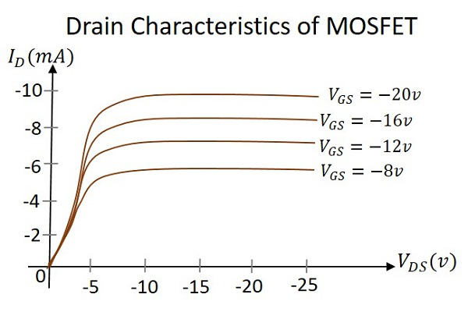

Actually when VDS is increased, the drain current ID should increase, but due to the applied VGS, the drain current is controlled at certain level. Hence the gate current controls the output drain current**.**

1.4**Transfer Characteristics**

Transfer characteristics define the change in the value of VDS with the change in ID and VGS in both depletion and enhancement modes. The below transfer characteristic curve is drawn for drain current versus gate to source voltage.

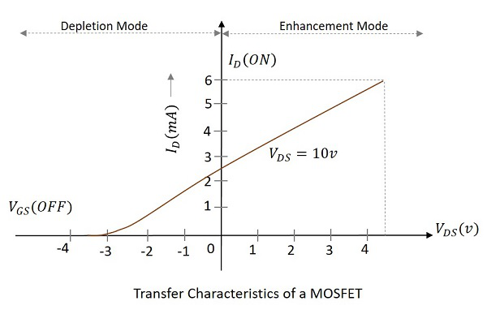

2. **HEMT**

HEMT or High Electron Mobility Transistor is a type of field effect transistor (FET) that is used to provide a combination of low noise figure and very high level of performance at microwave frequencies. This is an important device for high speed, high frequency and low noise applications in digital circuits and microwave circuits. These applications include computing, telecommunications, and instrumentation. The device is also used in RF design, where high performance is required at very high RF frequencies. HEMT looks 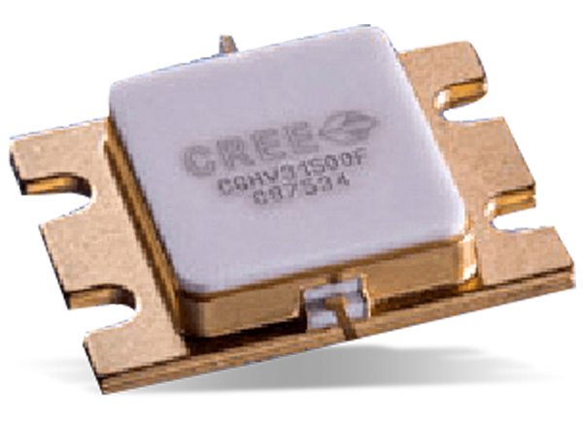like the following figure.

2.1 **High Electron Mobility Transistor (HEMT) Construction**

The key element that is used to construct an HEMT is the specialised PN junction. It is known as a hetero-junction and consists of a junction that uses different materials either side of the junction. Instead of the p-n junction, a metal-semiconductor junction (reverse-biased Schottky barrier) is used, where the simplicity of Schottky barriers allows fabrication to close geometrical tolerances

The most common materials used Aluminium Gallium Arsenide (AlGaAs) and Gallium Arsenide (GaAs). Gallium Arsenide is generally used because it provides a high level of basic electron mobility which has higher mobilities and carrier drift velocities than Si.

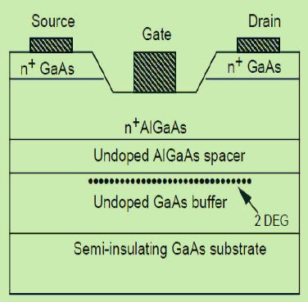

2.2 **HEMT OPERATIONS**

The operation of the HEMT is a bit different to other types of FET and as a result, it is able to give a very much enhanced performance over the standard junction or MOS FETs, and in particular in microwave RF applications. The electrons from the n-type region move through the crystal lattice and many remain close to the Hetero-junction. These electrons in a layer that is only one layer thick, forming as a two-dimensional electron gas shown in the above figure (a).

Within this region, the electrons are able to move freely, because there are no other donor electrons or other items with which electrons will collide and the mobility of the electrons in the gas is very high. The bias voltage applied to the gate formed as a Schottky barrier diode is used to modulate the number of electrons in the channel formed from the 2 D electron gas and consecutively this controls the conductivity of the device. The width of the channel can be changed by the gate bias voltage.

2.3 **Applications of HEMT**

* The HEMT was formerly developed for high-speed applications. Because of their low noise performance, they are widely used in small signal amplifiers, power amplifiers, oscillators and mixers operating at frequencies up to 60 GHz.
* HEMT devices are used in a wide range of RF design applications including cellular telecommunications, Direct broadcast receivers – DBS, radio astronomy, RADAR (Radio Detection and Ranging System) and majorly used in any RF design application that requires both low noise performance and very high-frequency operations.
* Nowadays HEMTs are more usually incorporated into integrated circuits. These Monolithic Microwave Integrated Circuit chips (MMIC) are widely used for RF design applications

2.4 **Characteristic Graph of HEMT**

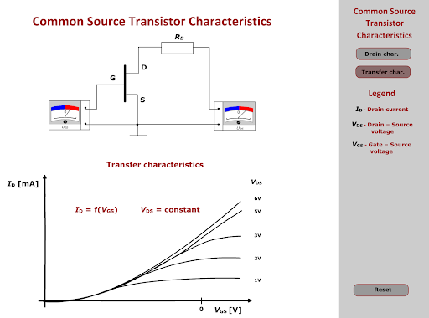

3.**COMPARISON**

MOSFET = Metal Oxide Semiconductor Field Effect Transistor

HEMT = High Electron Mobility Transistor

MOSFETs are the most common type of transistor in use today or in history. Most electronic devices you might use are made from them. A special form of MOSFET circuit called CMOS (Complementary MOS) dominates digital circuits because of it's low power consumption.

HEMT are high frequency transistors typically used in radio and microwave applications. The radio receivers for most cellphones, WiFi and similar systems use HEMT for analog radio signal amplification.

Both are "Field Effect Transistors" that use an electrostatic field created by applying a voltage to a gate terminal to modulate the current flowing between source and drain terminals. The differences involve the physical design and optimizations for specific applications.

**IV.Basic Class A amplifier using MOSFET**

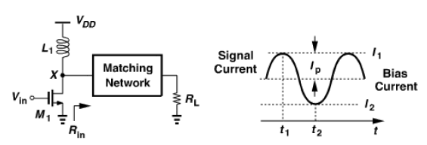Class A amplifiers are defined as circuits in which the transistors remain on and operate linearly across the full input and output range.

Note that the transistor bias current is chosen higher than the peak signal current Ip, to ensure that the device does not turn off at any time during the signal excursion. Ensuring that the amplifier is always on does not necessarily imply that the PA is always linear. In figure, if I1=5I2, the transistor transconductance varies considerably from t1 to t2 while the defination of class A comes to hold. This is where its defination becomes vague. Nonetheless, we can still assert that if linearity is required then class A operation is necessary.

Lets now compute the maximum drain (collector) efficiency of class A amplifiers. To reach maximum efficiency, we allow Vx to reach 2VDD and nearly zero. Thus, the power delivered to the matching network is approximately equal to (2VDD/2)2/(2Rin)=V2DD/(2Rin), which is also delivered to RL if the matching network is lossless. Also, the inductive load carries a constant current of Vdd/Rin from the supply voltage. Thus,

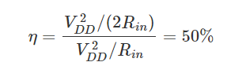

The other 50% of the supply power is dissipated by M1 itself.

Assumptions leading to an efficiency of 50% in class A stages are:

1. the drain (collector) peak to peak voltage swing is equal to twice the supply voltage i.e the transistor can withstand a drain-source (or collector-emitter) voltage of 2VDD with no reliability or breakdown issues.
2. the transistor barely turns off, i.e the non-linearity resulting from the very large change in the trans-conductance of the device is tolerable.
3. the matching network interposed between the output transistor and the antenna is lossless.

# V Stability of a System

The stability of a system is defined as the ability of any system to provide a bounded output when a bounded input is applied to it. More specifically, we can say, that stability allows the system to reach the steady-state and remain in that state for that particular input even after variation in the parameters of the system.

Stability is considered to be an important property of a control system. It is also referred as the system’s ability to reach the steady-state.

We can classify the systems based on stability as follows.

* Absolutely stable system
* Conditionally stable system
* Marginally stable system

Absolutely Stable System:

If the system is stable for all the range of system component values, then it is known as the absolutely stable system.

Conditionally Stable System:

If the system is stable for a certain range of system component values, then it is known as conditionally stable system.

Marginally Stable System:

If the system is stable by producing an output signal with constant amplitude and constant frequency of oscillations for bounded input, then it is known as marginally stable system.

Gain Margin:

The gain margin refers to the amount of gain, which can be increased or decreased without making the system unstable. It is usually expressed as a magnitude in dB. The greater the Gain Margin (GM), the greater the stability of the system.

Phase Margin:

The phase margin refers to the amount of phase, which can be increased or decreased without making the system unstable. It is usually expressed as a phase in degrees. The greater the Phase Margin (PM), the greater will be the stability of the system.

Bode Plot:

A Bode plot is a graph commonly used in control system engineering to determine the stability of a control system. A Bode plot maps the frequency response of the system through two graphs – the Bode magnitude plot (expressing the magnitude in decibels) and the Bode phase plot (expressing the phase shift in degrees).

Bode Plot Stability Criterion:

Gain Margin: Greater will the gain margin greater will be the stability of the system. It refers to the amount of gain, which can be increased or decreased without making the system unstable. It is usually expressed in dB.

Phase Margin: Greater will the phase margin greater will be the stability of the system. It refers to the phase which can be increased or decreased without making the system unstable. It is usually expressed in phase. 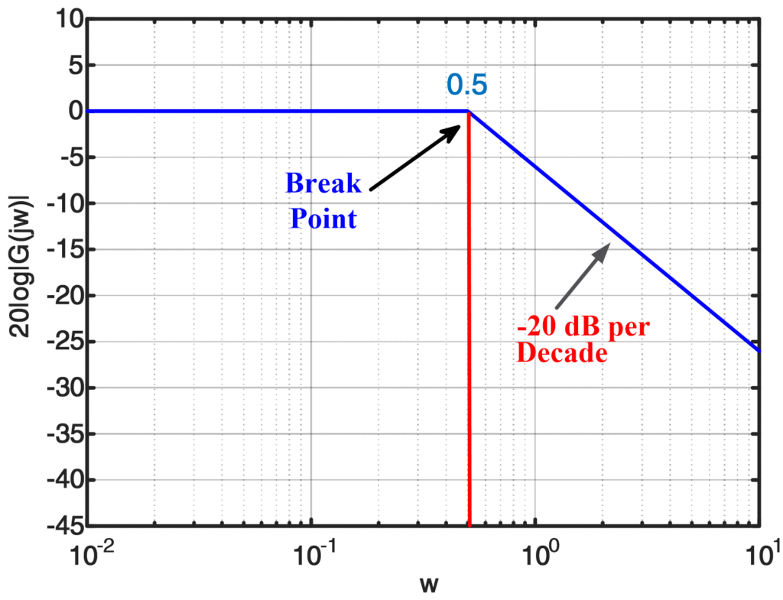

BODE PLOT

Pole-Zero Concept:

The frequencies for which the values of denominator and nominator become zero in a transfer function are called Poles and Zeros. Poles and Zeros analyze the performance of a system and check the stability. The values of Poles and Zeros control the working of a system. Usually the numbers of Poles and Zeros are equal in a system and in some cases number of Poles is greater.

Definition of Poles:

Poles are the roots of the denominator of a transfer function. Taking a simple transfer function as an example:

Difference between Poles and Zeros of a Control System 2

Here Poles are the roots of D(s) and can be evaluated by taking D(s) = 0 and is solved for s. Generally, the number of Poles is equal or greater than Zeros. When s approached a pole the value of denominator becomes Zero making the value of transfer function reach infinity.

To determine the response, a system the location of Poles is analyze along with the values of real and imaginary parts of each pole. Real part determines the exponential and imaginary part determines sinusoidal values.

Definition of Zeros:

Similar to Poles, Zeros are the roots of nominator of a transfer function. For same above transfer function Zeros can be determined by taking N(s) = 0 and solving for s. The number of Zeros is lesser or equal to the Poles. Zeros mean that the output at those frequencies is zero.

Polar Plot:

The Polar plot is a plot, which can be drawn between the magnitude and the phase angle of G(jω)H(jω) by varying ω from zero to ∞. It is used for stability analysis. The locus of tip of the phasor with frequency is called the polar plot. Hence the polar plot contains entire frequency response characteristics in a single plot. It can determine closed loop stability using open loop transfer function. But it cannot determine the number of roots causing instability to the system.

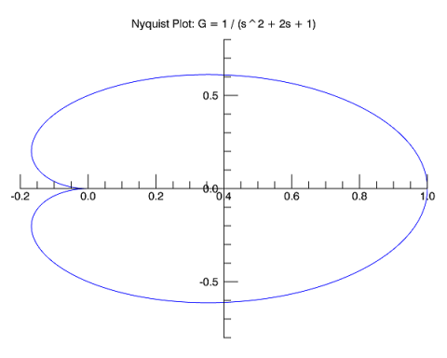

POLAR PLOT

**VI Noise**

Definition: Noise in a communication system is basically undesirable or unwanted signals that get randomly added to the actual information carrying signal. Resultantly, causes disturbances in the original signal being transmitted from an end to another.

The presence of noise in the system causes**interference** in the signal being transmitted and this ultimately causes errors in the communication system.

Practically, the addition of noise over the information carrying signal is an unavoidable phenomenon. And this interference automatically hinders the quality of the signal being transmitted.

Due to the reduction in the quality of signal the receiver experiences difficulty in demodulating the transmitted signal. This eventually reduces system efficiency.

Now, the question arises how can we distinguish the various types of noise signals. So let us move further to understand the types of noise.

Types of Noise in Communication System

Noise in the communication system is mainly classified on the basis of the source that generates that noise.

So, on the basis of source noise in the communication channel are of 2 types:

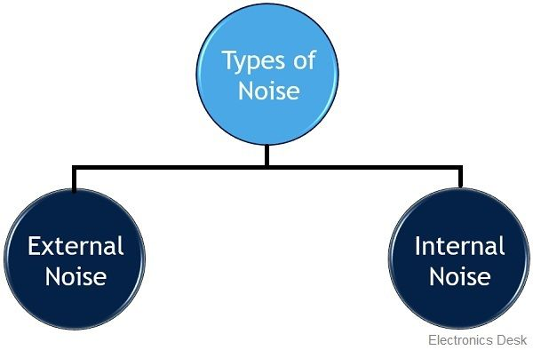

1. ***External noise*** includes**natural noise** and man-made noise.

Natural Noise

Natural noise gets generated due to either natural phenomenon or atmospheric actions like solar flares, radiation in space, electronic storms etc.

It is further classified into atmospheric and extraterrestrial noise.

Atmospheric Noise

The atmospheric actions produce false or spurious signals that get added with the original signal thereby causing interference in the information signal. These spurious signals propagate in the same manner as the original signal.

Hence the receiver at the other end collects both message as well as spurious signals.

Extraterrestrial Noise

This type of noise is generated by either the sun or the outer space. This type of noise is classified into two categories:

**Solar Noise**: Solar noise is generated by the sun. As Sun is a large body with extremely high temperature thus it emits or releases high electrical energy in noise form over a broad frequency range.

However, the intensity of the produced noise signal changes timely. This is so because the temperature change of the sun follows 11 years of the life cycle. Hence large electrical disturbances occur after the period of every 11 years. While at other years the noise level is comparatively low.

**Cosmic Noise**: This noise originates from the stars present in the outer space. As distant stars are also very high-temperature bodies and are also termed as the sun. The noise generated from the star is similar to that generated from the sun. Cosmic noise is also known as **black body noise**.

Not only the stars but the galaxies and other virtual point sources like **quasars** and**pulsars** in the outer space produces cosmic noise.

Man-made noise

This type of extrinsic noise is also known as industrial noise. These are basically the electrical noise that gets produced by the wear and tear of the circuit being used. The source of man-made noise is electric motors, high current circuits, florescent lights switch gears etc.

When these machines operate, arc discharge takes place and this discharge generates noise signals in the communication system.

The frequency spectrum of man-made noise lies between **1 MHz** to **600 MHz**.

**2** ***Internal Noise*** is the fundamental noise that gets generated by the electronic equipment involved in the system itself. They are called so because these are nothing but an integral part of the system.

Proper designing of the communication system can reduce or overcome noise due to internal sources.

Internal Noise is classified as follows:

Thermal Noise

As we already know that an electrical signal is transmitted through a channel by the help of conductors. So, the electrons present in the conductors move randomly.

The random motion of the electrons is the reason for the thermal energy received by the conductor. However, these free electrons are non-uniformly distributed within the conductor.

Due to this a possibility also exist that at one end the number of free electrons will be comparatively higher than at the other end.

This non-uniform distribution of electrons provides the average voltage to be zero, however, the average power is not zero in this case.

So, this non zero power is nothing but the noise. And as it is the outcome of thermal action. Hence also known as thermal noise power. Thermal noise is sometimes referred as **Johnson noise** or **white noise**.

Shot Noise

Shot noise in a communication channel is the result of random variation in the appearance of electrons and holes at the output side of the device. These random movements are the result of discontinuities in the device which is being used by the system.

The shot noise generates sound like several lead shots are striking over a metal plate or tube.

It also occurs in pn junction diodes, as though movement of carriers within the diode is due to the action of an external potential. But, sometimes their random movement generates shot noise.

Thus we can say non-linearity or discontinuity in the system generates shot noise.

Partition Noise

Here the name itself is indicating the cause for generation of this type of noise.

As it gets generated when the system is composed of multiple paths, and during the flow, the current gets divided in these paths. These are nothing but the result of random variation in the divisions. Due to this reason some devices offer low partition noise while some offers, high.

Flicker Noise

It is also known as low-frequency noise and it occurs because of the variation in the carrier density. Due to this variation or fluctuation, the conductivity of the material gets varied.

So, when a direct current is allowed to flow through the conductor then fluctuating voltage drop across in the conductor results in flicker noise voltage.

It is to be noteworthy here that, **the mean square of flicker noise voltage is directly proportional to the square of the current** flowing through the device.

Transit Time Noise

It is also known as high-frequency noise. It arises when the charge carriers require comparatively more time to travel from one end to another within the conductor. This effect is called **transit time effect**.

For low-frequency applications, this effect is avoidable but for high-frequency applications the effect is unavoidable. Due to this transit time effect, random noise gets generated inside the device and is known as transit time noise.

**VII Simulation of Basic Circuits**

1. LOW PASS FILTER:

SCHEMATIC OF LOW PASS FILTER

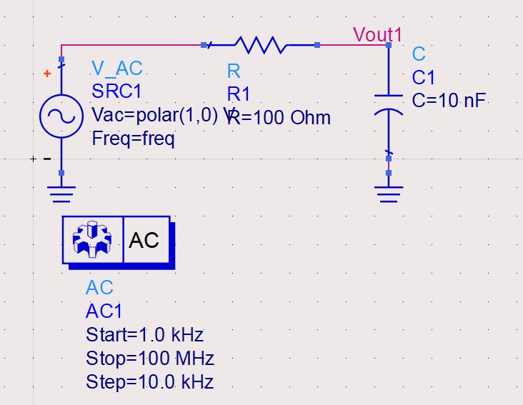

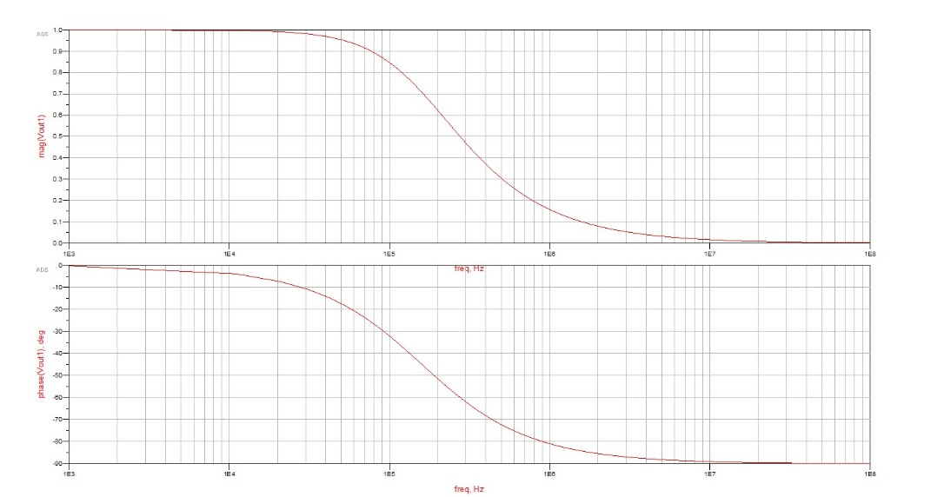

CHARACTERISTIC PLOTS OF LOW PASS FILTER

SCHEMATIC OF LOW PASS FILTER

*Inference*: By definition, a low-pass filter is a circuit offering easy passage to low-frequency signals and difficult passage to high-frequency signals

All low-pass filters are rated at a certain cutoff frequency. That is, the frequency above which the output voltage falls below 70.7% of the input voltage. This cutoff percentage of 70.7 is not really arbitrary, all though it may seem so at first glance.

In a simple capacitive/resistive low-pass filter, it is the frequency at which capacitive reactance in ohms equals resistance in ohms. In a simple capacitive low-pass filter (one resistor, one capacitor), the cut-off frequency is given as:

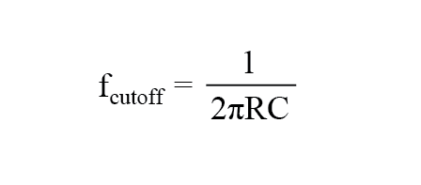

Therefore, from the plot we can conclude that:

**Expected** cut-off frequency:**116** KHz

**Actual** cut-off frequency: **111** KHz (approximately)

1. High Pass Filter:

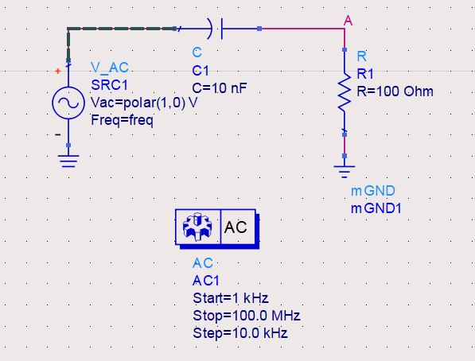

SCHEMATIC DIAGRAM OF HIGH PASS FILTER

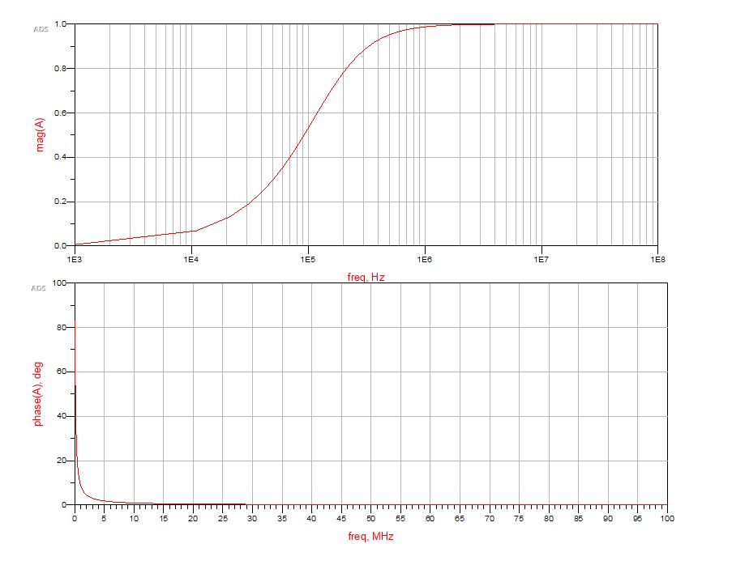

CHARACTERSTICS PLOTS OF HIGH PASS FILTER

*Inference:* A high-pass filter’s task is just the opposite of a low-pass filter: to offer easy passage of a high-frequency signal and difficult passage to a low-frequency signal.

Cutoff Frequency

As with low-pass filters, high-pass filters have a rated cutoff frequency, above which the output voltage increases above 70.7% of the input voltage. Just as in the case of the capacitive low-pass filter circuit, the capacitive high-pass filter’s cutoff frequency can be found with the same formula:

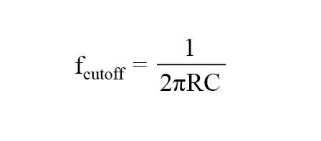

In the example circuit, there is no resistance other than the load resistor, so that is the value for R in the formula.

Therefore, from the plot we can conclude that:

**Expected** cut-off frequency:**116** KHz

**Actual** cut-off frequency: **131** KHz (approximately)

1. Band Stop Filter:

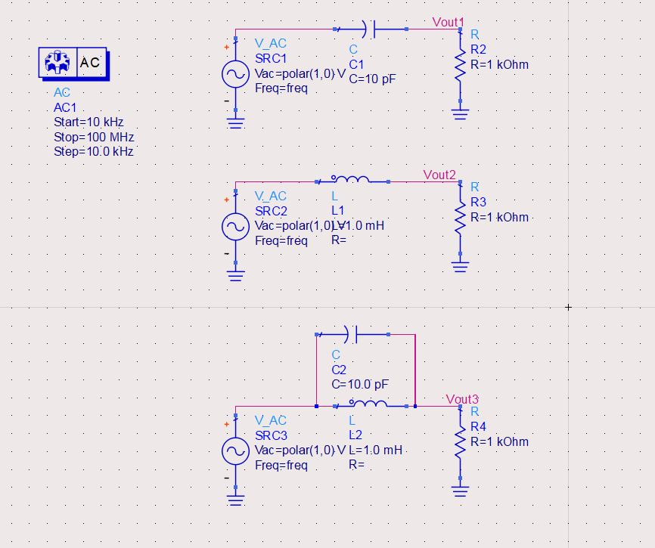

SCHEMATIC DIAGRAM OF BAND STOP FILTER

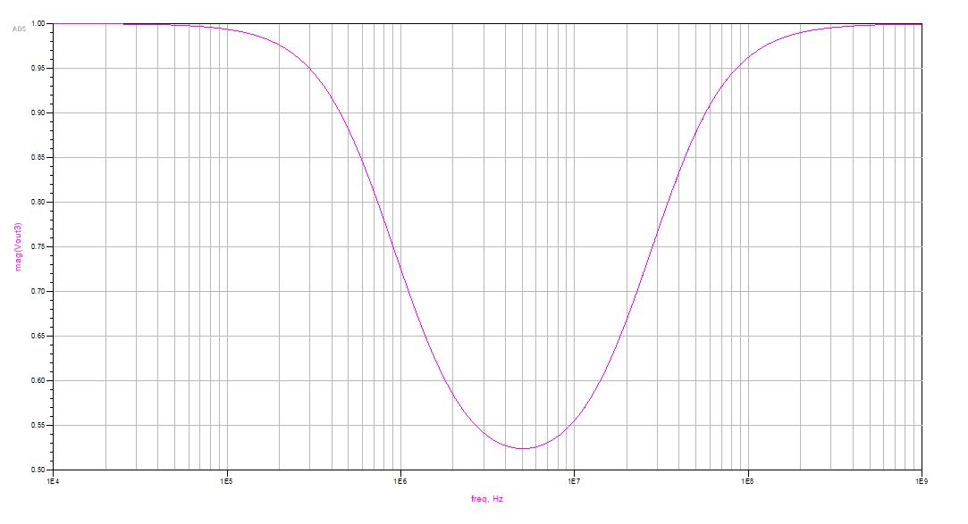

CHARACTERSTIC PLOT OF BAND STOP FILTER

*Inference:* A band Stop Filter known also as a Notch Filter, blocks and rejects frequencies that lie between its two cut-off frequency points passes all those frequencies either side of this range.

The upper and lower cut-off frequency points for a band stop filter can be found using the same formula as that for both the low and high pass filters as shown.

Therefore, from the plots we can infer that the circuit is stable.

1. Band Pass Filter:

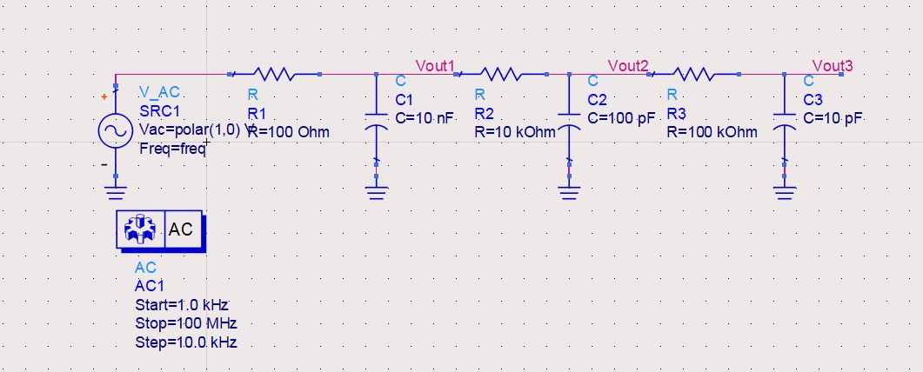 d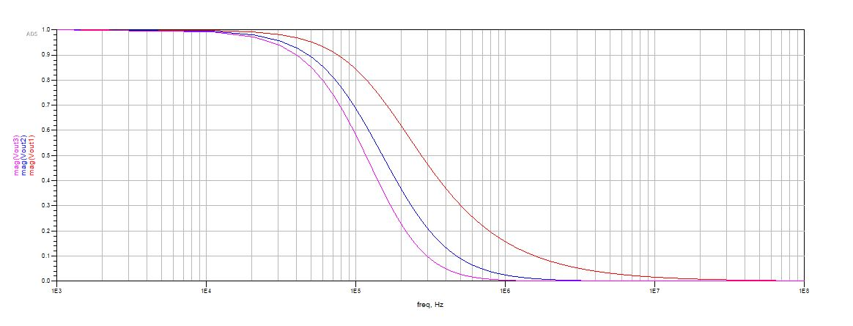

SCHEMATIC DIAGRAM OF BAND PASS FILTER

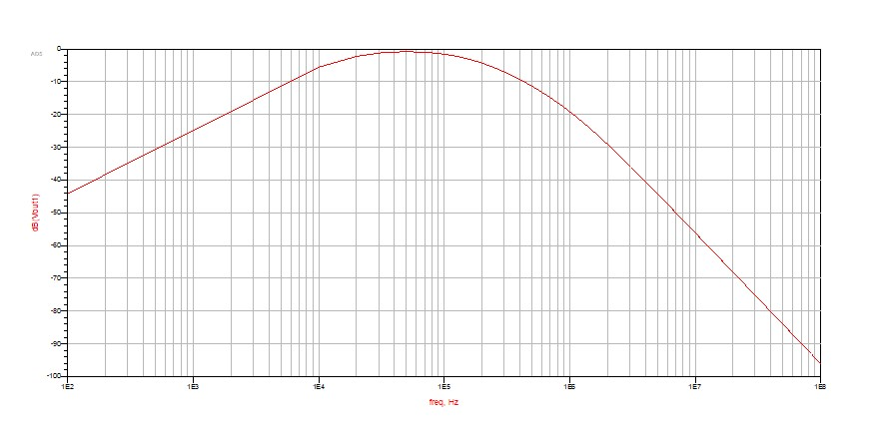

CHARACTERSTIC PLOT OF BAND PASS FILTER

*Inference:* Band Pass Filters can be used to isolate or filter out certain frequencies that lie within a particular band or range of frequencies. The cut-off frequency or ƒc point in a simple RC passive filter can be accurately controlled using just a single resistor in series with a non-polarized capacitor, and depending upon which way around they are connected, we have seen that either a Low Pass or a High Pass filter is obtained

The upper and lower cut-off frequency points for a band stop filter can be found using the same formula as that for both the low and high pass filters as shown.

Therefore, from the plots we can infer that the circuit is stable.

**VIII. Simulations of complex circuits**

1. Op-amp based filter circuit

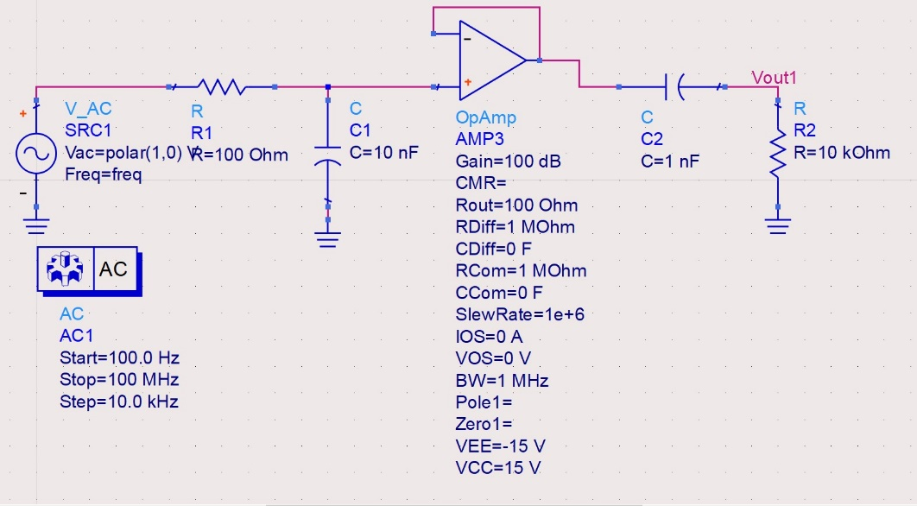

SCHEMATIC DIAGRAM OF OP AMP BASED FILTER

CHARACTERISTIC PLOT OF THE CIRCUIT



CHARACTERISTICS GRAPH OF THE CIRCUIT

*Inference:* The principal characteristic of an **Op-Amp based** **Band Pass Filter** or any filter for that matter, is its ability to pass frequencies relatively unattenuated over a specified band or spread of frequencies called the “Pass Band”.

The cut-off or corner frequency of the low pass filter (LPF) is higher than the cut-off frequency of the high pass filter (HPF) and the difference between the frequencies at the -3dB point will determine the “bandwidth” of the band pass filter while attenuating any signals outside of these points.

The upper and lower cut-off frequency points for a band stop filter can be found using the same formula as that for both the low and high pass filters as shown.

Therefore, from the plots we can infer that the circuit is stable.

1. Cascode Amplifier:

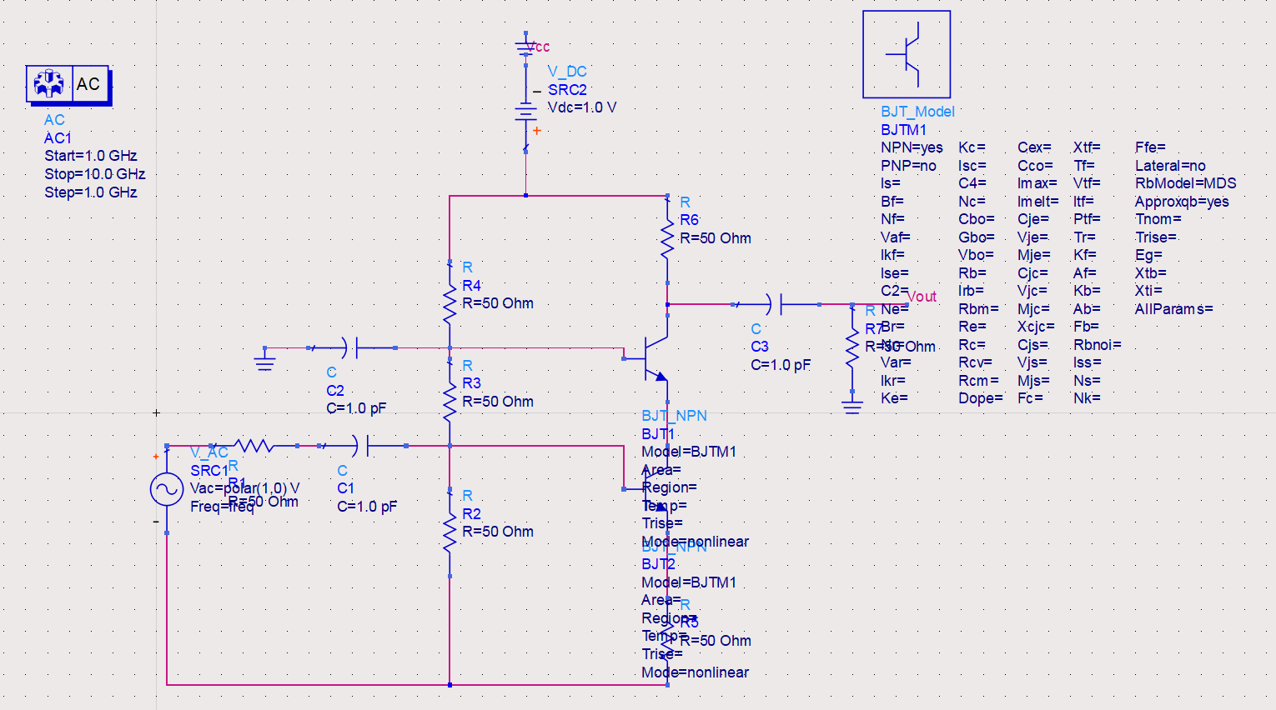

SCHEMATIC DIAGRAM OF CASCODE AMPLIFIER

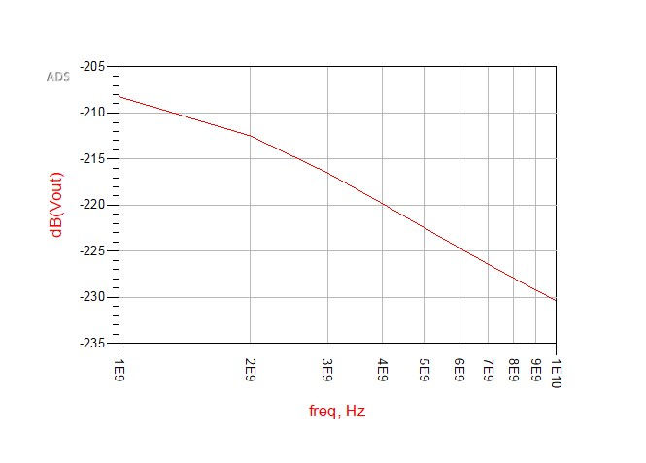

CHARACTERISTIC GRAPH OF THE CIRCUIT

*Inference:* The cascode is a two-stage amplifier that consists of a common-emitter stage feeding into a common-base stage.[1][2]

Compared to a single amplifier stage, this combination may have one or more of the following characteristics: higher input–output isolation, higher input impedance, high output impedance, higher bandwidth.

In modern circuits, the cascode is often constructed from two transistors (BJTs or FETs), with one operating as a common emitter or common source and the other as a common base or common gate. The cascode improves input–output isolation (reduces reverse transmission), as there is no direct coupling from the output to input. This eliminates the Miller effect and thus contributes to a much higher bandwidth.

1. Low Noise Amplifier:

SCHEMATIC DIAGRAM OF LOW NOISE AMPLIFIER

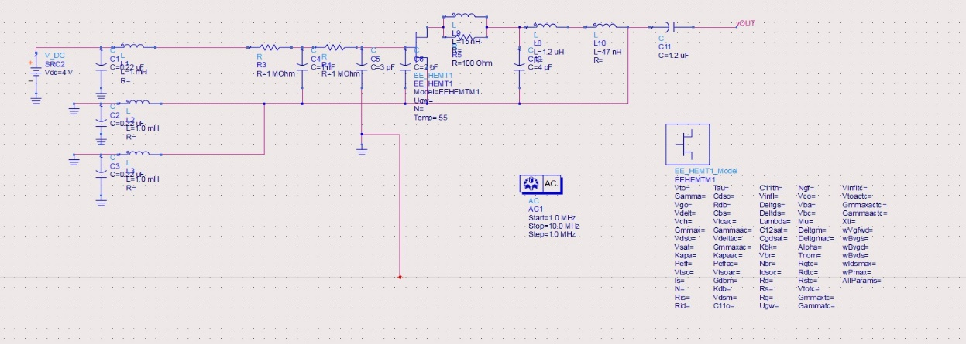

SCHEMATIC DIAGRAM OF LOW NOISE AMPLIFIER

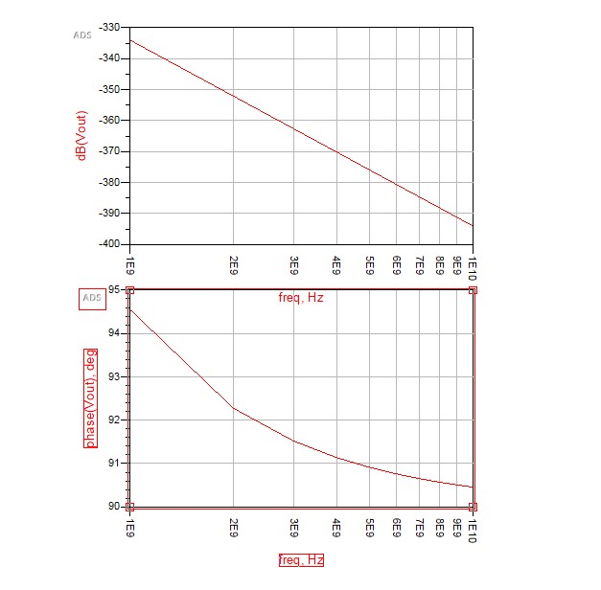

CHARACTERISTIC GRAPH OF THE CIRCUIT

*Inference:* A low-noise amplifier is an electronic amplifier that amplifies a very low-power signal without significantly degrading its signal-to-noise ratio. An amplifier will increase the power of both the signal and the noise present at its input, but the amplifier will also introduce some additional noise

Analog Devices low noise amplifiers cover the frequency range from DC (IF) to RF Microwave and W-Band (95 GHz). These MMIC-based designs cover various gains and bandwidths with noise figures as low as 0.7 dB. Our low noise amplifiers offer some of the lowest noise and highest linearity available in the industry. Many of the designs offer a self-biased topology, and are internally matched to 50 ohms. They are used in a wide range of applications including telecom, instrumentation, and military/aerospace. All Analog Devices low noise amplifiers are fully specified over frequency, temperature, and supply voltage.

**IX. Conclusion**

## Bode Stability Criterion

Stability conditions are given below:

1. For a Stable System: Both the margins should be positive or phase margin should be greater than the gain margin.
2. For Marginal Stable System: Both the margins should be zero or phase margin should be equal to the gain margin.
3. For Unstable System: If any of them is negative or **phase margin** should be less than the gain margin.

## Advantages of a Bode Plot

1. It is based on the asymptotic approximation, which provides a simple method to plot the logarithmic magnitude curve.
2. The multiplication of various magnitude appears in the transfer function can be treated as an addition, while division can be treated as subtraction as we are using a logarithmic scale.
3. With the help of this plot only we can directly comment on the stability of the system without doing any calculations.
4. **Bode plots** provide relative stability in terms of **gain margin** and **phase margin**.
5. It also covers from low frequency to high frequency range.

**Low-Noise Amplifier**

A low-noise amplifier (LNA) is commonly found in all receivers. Its role is to boost the received signal a sufficient level above the noise floor so that it can be used for additional processing. The noise figure of the LNA therefore directly limits the sensitivity of the receiver.The main application is to reduce the Miller effect.

Thus, all the circuits were simulated successfully and the graphs were plotted.